EX:No.9 221501021

Develop neural network-based time series forecasting model.

Aim:
Write a program todevelop neural network-based time series forecasting model.
Algorithm:
1.Import required libraries:
Import numpy, pandas, matplotlib, MinMaxScaler from sklearn, and neural network layers from tensorflow.keras.
2.Load the dataset:
Read the CSV file containing weather data and parse the 'Date' column as datetime while setting it as the index.
3.Select the target column:
Extract the 'Temperature' column as the target for forecasting.
4.Normalize the data:
Scale the temperature values to a range between 0 and 1 using MinMaxScaler to improve neural network performance.
5.Create sequences:
Define a function that converts the scaled data into sequences of a specified number of time steps (TIME_STEPS = 10) and corresponding labels (next temperature value).
6.Split the data:
Divide the sequence data into training (80%) and testing (20%) sets.
7.Build the LSTM model:
Create a sequential model with an LSTM layer (50 units, ReLU activation) followed by a dense output layer with one neuron. Compile the model using the Adam optimizer and mean squared error loss.
8.Train the model:
Fit the model on the training data for 20 epochs.
9.Make predictions:
Use the trained model to predict temperature values on the test set.
10.Inverse scale the predictions:
Convert the scaled predictions and actual values back to the original scale using the inverse of MinMaxScaler.
11.Visualize the results:
Plot the actual vs. predicted temperature values to evaluate model performance visually.

Code:

import numpy as np
import pandas as pd
import matplotlib.pyplot as plt
from sklearn.preprocessing import MinMaxScaler
from tensorflow.keras.models import Sequential
from tensorflow.keras.layers import Dense, LSTM

# Load and prepare the data
# Assuming the date column is named 'Date' and not 'Month'
# If your date column has a different name, replace 'Date' with the actual name
try:
df = pd.read_csv("/content/MSFT.csv", parse_dates=['Date'], index_col='Date')
except KeyError:
# If 'Date' column is not found, try using 'Month'
try:
df = pd.read_csv("/content/MSFT.csv", parse_dates=['Month'], index_col='Month')
except KeyError:
print("Error: Neither 'Date' nor 'Month' column found in CSV for parsing dates.")
exit(1)

# Check if '#Passengers' or 'Close' columns exist, otherwise print available columns
data_column = None
if '#Passengers' in df.columns:
data_column = '#Passengers'
elif 'Close' in df.columns:
data_column = 'Close'
else:
print("Error: Neither '#Passengers' nor 'Close' columns found in CSV. Available columns:")
print(df.columns)
exit(1)

data = df[[data_column]].values

# Normalize the data
scaler = MinMaxScaler(feature_range=(0, 1))
data_scaled = scaler.fit_transform(data)

# Create sequences
def create_sequences(data, time_steps=10):
X, y = [], []
for i in range(len(data) - time_steps):
X.append(data[i:i + time_steps])
y.append(data[i + time_steps])
return np.array(X), np.array(y)

TIME_STEPS = 10
X, y = create_sequences(data_scaled, TIME_STEPS)

# Train/test split
split = int(0.8 * len(X))
X_train, X_test = X[:split], X[split:]
y_train, y_test = y[:split], y[split:]

# Build the LSTM model
model = Sequential()
model.add(LSTM(50, activation='relu', input_shape=(TIME_STEPS, 1)))
model.add(Dense(1))
model.compile(optimizer='adam', loss='mse')

# Train the model
model.fit(X_train, y_train, epochs=20, verbose=1)

# Predict
predicted = model.predict(X_test)

# Inverse transform predictions and true values
predicted_unscaled = scaler.inverse_transform(predicted)
y_test_unscaled = scaler.inverse_transform(y_test)

# Plot the results
plt.figure(figsize=(12, 6))
plt.plot(y_test_unscaled, label='Actual')
plt.plot(predicted_unscaled, label='Predicted')
plt.title('LSTM Forecasting')
plt.xlabel('Time Steps')
plt.ylabel(data_column) # Use the determined data column name for the y-axis label
plt.legend()
plt.grid(True)
plt.tight_layout()
plt.show()

Output:

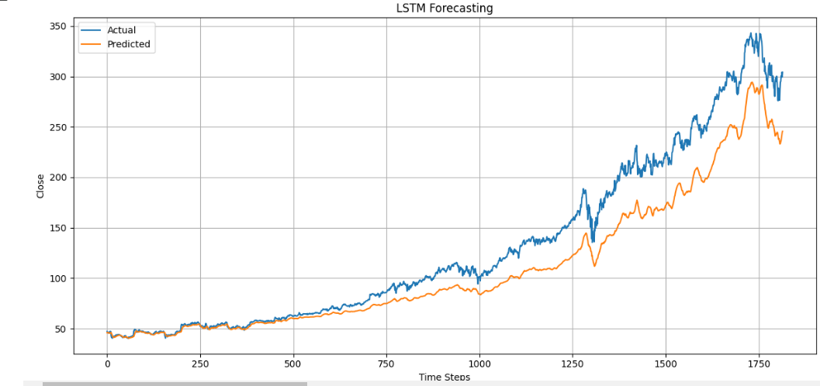

Result:
Thus, the program todevelop neural network-based time series forecasting modelwas done.

